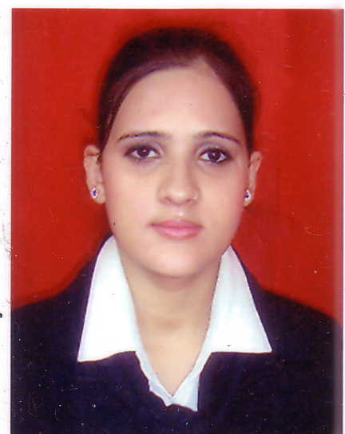
DeepmalaSinha,
Tirupati Dhara Appt,
Navi Mumbai
Mobile: 91 8879469627
deepmalasinha86@gmail.com

My Objective
To work in a progressive environment cultivating my potential and abilities. As a professional, I believe in intellectually stimulating work process, enhancing value addition to my job and the organization.

Attitude towards work
Hard work has no substitution.
Hobbies Listening music, Singing, Drawing/Painting.
Strength Positive Attitude, Amicable, Enthusiastic, Assertive
Educational background
Level | Year of passing | Board | Percentage
X | 2002 | C.B.S.E | 59
XII | 2004 | C.B.S.E | 66.5
Graduation | 2011 | B.B.A | 65

Professional Qualification
Completed Two years diploma in Aviation & Hospitality from the Air Hostess Academy (AHA), New Delhi
Work Experience
Working as Business Development Coordinator with DSC Ltd., Gurgaon (Since 2009)

Job Responsibility
- Screening telephone calls and handling inquiries.
-Organizing the manager diary and making appointments.
-Drafting letters & emails.
-Organizing meetings
-Organizing and maintaining office systems
-Making travel arrangements.
-Looking after visitors.
-Looking into administration activities also.

-Making MIS Report.

-Preparing Inter- office Memo

-Attending meetings (BD team) and maintaining files

Worked as Guest Relation Executive with the Taj Palace Hotel, New Delhi

Job Responsibility
. Interact with all guests
. Offer personalized welcome and departure to all guests
. Identify the guests and make them feel at home.
. Support the PR team of the hotel.
. Resolve guest complaints or problems whenever possible.
. Show around of the hotel to the guests.
. Meeting guests who are ill, or on occasions such as birthdays, anniversaries etc.
. Entertain the guest in the hotel restaurant as and when encountered problems
Languages Known
Hindi, English

Personal Details
Husband's Name Mr. Avanish Kumar jha
Age 27
Gender Female
Status Married
Nationality India Deepmala Sinha

